AC susceptometry in study of phase transitions and magnetic relaxation

in low-dimensional and molecular magnets

**Doc.Maria Bałanda, DSc**., Institute of Nuclear Physics, Polish Academy of Sciences

Kraków, Poland

I. Definitions, experimental, nonlinear susceptibilities - study of phase transitions

II. Magnetic relaxation - slow relaxation in Single Molecule Magnets and Single Chain Magnets

III. Magnetic relaxation in real spin systems - spin glasses, quasi 1-dimensional systems with phase

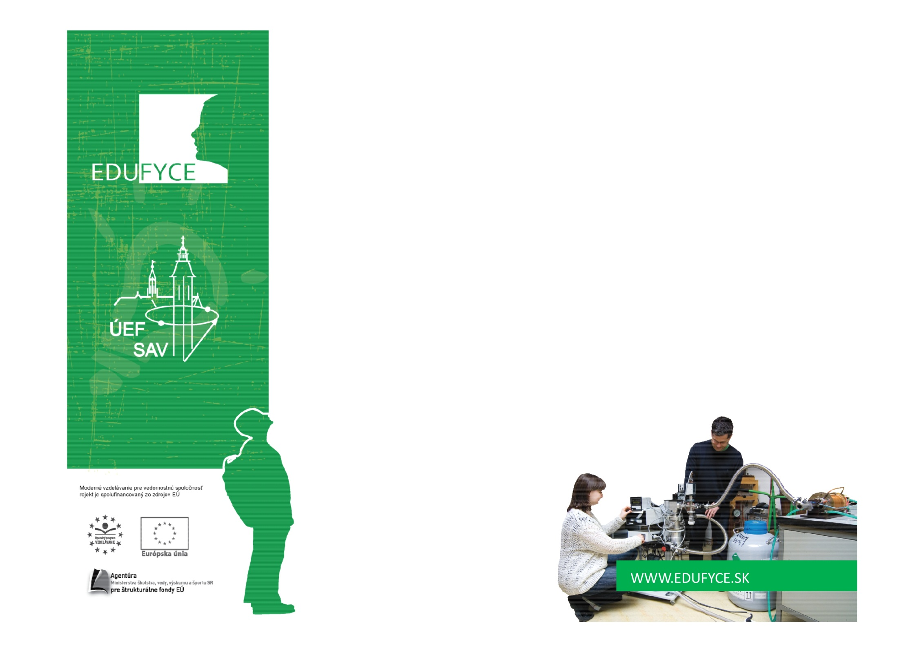 transition to the ordered phase, nanoparticles

**Prednášky sa budú konať**

**20.11.2012** od 13,30- 15,30 miest.č.101,(malá zasadačka ) Watsonova 47, 1.posch

**22.11.2012** od 10,30 – 12,00 Videokonferenčná miestnosť, Watsonova 47, 1.posch.

**23.11.2012** od 10,30-12,00 miest.č.101,(malá zasadačka ) Watsonova 47, 1.posch